វិទ្យាស្ថានបច្ចេកវិទ្យាកម្ពុជា

Institute of Technology of Cambodia

Department of Information and Communication

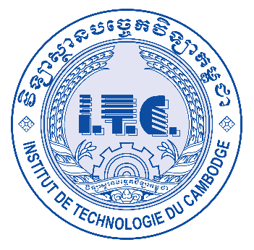

Subject: Internet Programming

Professor: HOK TIN

Assignment: TP3 (Local, cookie and session storage)

Name: LAY Vicha

ID: e20190494

Group: I4-GIC-B

2022-2023

Contents

1. EX1-Local storage 1

2. EX2-Session storage 2

3. EX3-Cookie storage 3

4. EX4-Book shop CRUD with Local storage 4

5. EX5-Login form with cookie 5

# EX1-Local storage

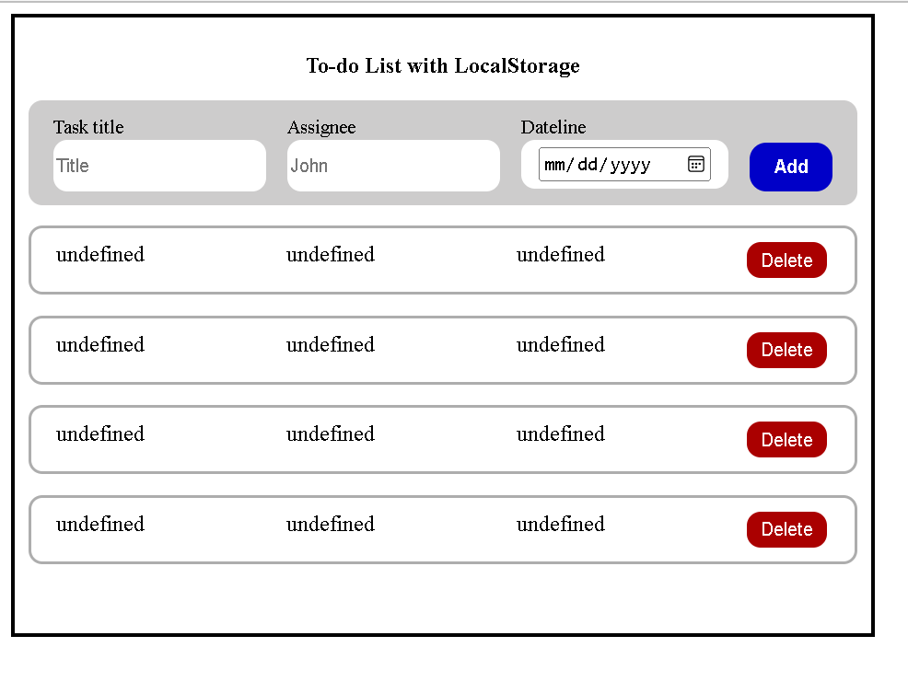

# EX2-Session storage

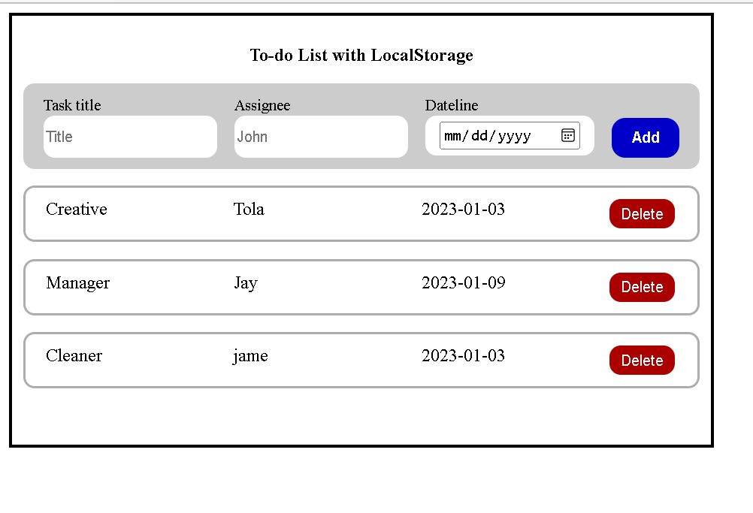

# EX3-Cookie storage

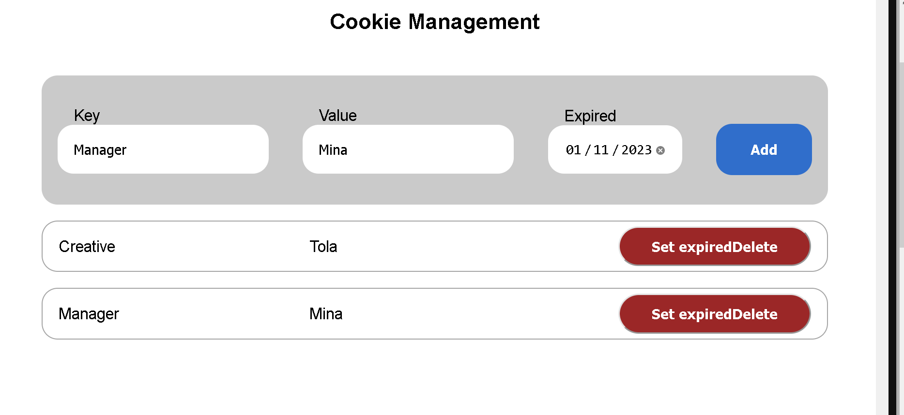

# EX4-Book shop CRUD with Local storage

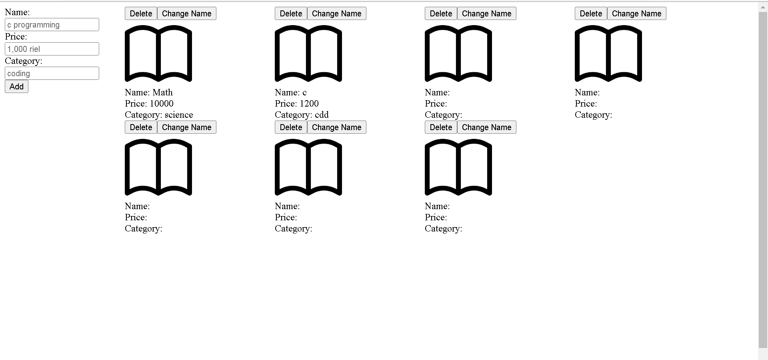

# EX5-Login form with cookie

